006BC2744 - Day 16 (6 August 2026)

Task 1: In yesterday's project can you implement a custom pipe to mask the account number..

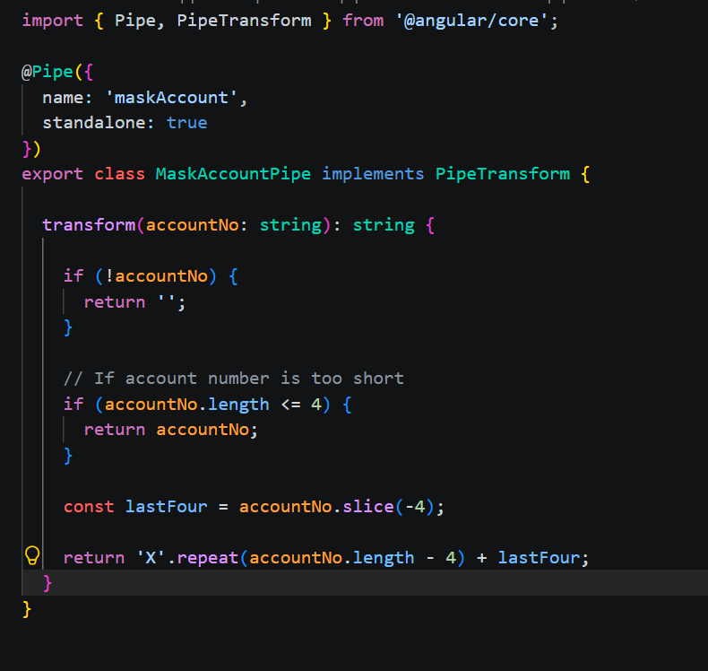

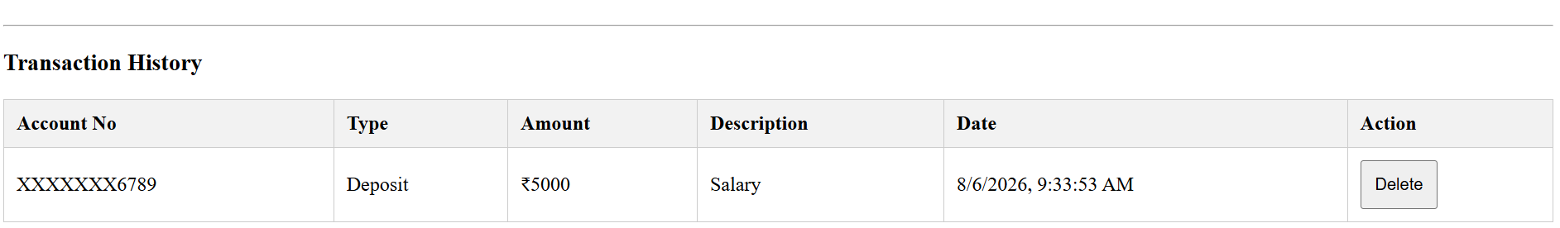

Task 2: Also use a currency pipe for the amount.
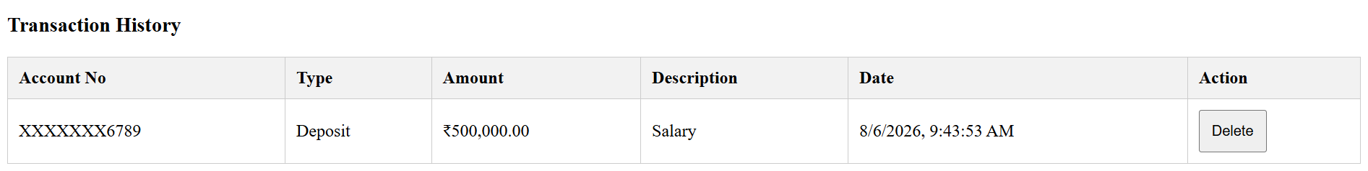

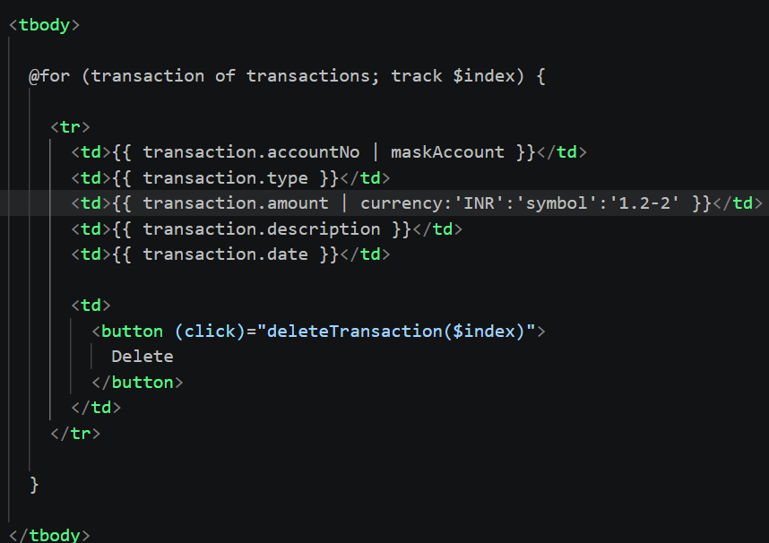

Task 3: Create a service banking.service.ts
Http requests.. Use the Crud operations for – post , get, delete, patch ….

Added code on github

Task 4: Create authentication for your account’s id and password..
For eg : auth.service.ts

And then add a protection card to your auth.service - like if he is a valid user he has to see the transactions..
Name it as auth.gaurd.ts

Task 5: Create a shared module for all your pipes to be bundles ..
For eg:
shared.module.ts

Task 6: Create auth.module.ts for your login and register components.ts

